CHAPTER 13
CHI-SQUARE APPLICATIONS

SECTION EXERCISES
13.1 d/p/e Chi-square analysis can be used for: goodness of fit tests to examine whether a sample could be from a specified population, testing the independence of two variables, comparing proportions from two or more independent samples, and tests involving the population variance.

13.2 d/p/e The chi-square distribution is a family of distributions which take on different shapes according to the associated degrees of freedom. A given chi-square distribution is a continuous curve and chi-square is always positive.

13.3 d/p/e The chi-square distribution is continuous and approaches the normal distribution as d.f. increases.

13.4 d/p/m A chi-square distribution with a small d.f. will be very positively skewed. The distribution with 100 d.f. will approach a normal distribution.

13.5 d/p/m The chi-square statistic can never be negative. Recall that any number squared is positive.

13.6 c/p/e This problem requires the table for the chi-square distribution found in the appendix.
The appropriate values for A with 5 degrees of freedom are:
a. A = 1. 610 d. A = 11.070
b. A = 9.236 e. A = 12.833
c. A = 1.145 f. A = 0. 831

13.7 c/p/e This problem requires the chi-square distribution table found in the appendix. The appropriate values for A with 8 degrees of freedom are:
a. A = 3.490 d. A = 15.507
b. A = 13.362 e. A = 17.535
c. A = 2.733 f. A = 2.180

13.8 c/p/m This problem requires the chi-square distribution table found in the appendix. The tail area must be divided in half to account for each tail. The appropriate values for A and B with 10 degrees of freedom are:
a. A = 4.865 B = 15.987 c. A = 3.247 B = 20.483
b. A = 3.940 B = 18.307 d. A = 2.558 B = 23.209

13.9 c/p/m This problem requires the chi-square distribution table found in the appendix. The tail area must be divided in half to account for each tail. The appropriate values for A and B with 15 degrees of freedom are:
a. A = 8.547 B = 22.307 c. A = 6.262 B = 27.488
b. A = 7.261 B = 24.996 d. A = 5.229 B = 30.578

13.10 d/p/m Given k is the number of categories or groups in the test, and m is the number of population parameters that must be estimated from sample data in order to carry out the test. "k - 1" is present because, if we know the total number of observations, we need only know the contents of "k - 1" cells to determine the count in the k^{th} cell. In addition, each population parameter that must be estimated also reduces our degrees of freedom.

13.11 d/p/mThe calculated chi-square will be very small if the expected frequencies differ very little from the observed frequencies. A small test statistic results in a "fail to reject the null hypothesis" decision, and this is what we expect if the differences between the observed and expected frequencies are small. The formula for the test statistic also shows why this calculated chi-square will be small -- each difference between the observed and expected frequencies squared and divided by the expected frequencies will be small, and the sum of several small numbers is a small number.

13.12 c/p/m The degrees of freedom are k - 1 - m. In this case, k = 8, and m = 0, so the appropriate value is d.f. = 8 - 1 - 0 = 7.

13.13 c/p/m The degrees of freedom are k - 1 - m. For this problem, k = 5, and m = 0, so the appropriate value is d.f. = 5 - 1 - 0 = 4.

13.14 c/p/m
a. The appropriate degrees of freedom are 5 - 1 - 2 = 2. (m = 2 since we have to estimate the mean and standard deviation to compute our expected frequencies.)
b. The critical value of chi-square with 2 degrees of freedom and α = 0.05 is 5.991.
c. Since the calculated value exceeds the critical value, we reject the null hypothesis and conclude that there is evidence to suggest, at the 0.05 level, that the sample was not drawn from a normal population.

13.15 c/p/m
a. The degrees of freedom are 8 - 1 - 1 = 6. (m = 1 in this case since we have to estimate the standard deviation to compute our expected frequencies.)
b. The critical value of chi-square with 6 degrees of freedom and alpha = 0.05 is 12.592.
c. Since the calculated value is less than the critical value, we fail to reject the null hypothesis and conclude, at the 0.05 level, that there is no evidence to suggest that the sample was not drawn from a normal population.

13.16 p/a/m The null and alternative hypotheses are:
H₀: The geographical distribution of hotline callers is the same as the U.S. population distribution.
H₁: The geographical distribution of hotline callers is not the same as the U.S. population.
The degrees of freedom are 4 - 1 - 0 = 3, and the critical chi-square value at the 0.05 level is 7.815.
The calculations are shown below.
region | observed | expected | calculated*
Northeast | 39 | 36.20 | 0.217
Midwest | 55 | 43.80 | 2.864
South | 60 | 73.40 | 2.446
West | 46 | 46.60 | 0.008
 |  |  | 5.535
*Note that the "calculated" column is 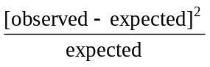 and the sum at the bottom of the "calculated" column is the calculated chi-square for this problem. The individual contributions, and the sum in the fourth column, are shown here rounded to three decimal places. Since the calculated value (5.535) is less than the critical value (7.815), we fail to reject the null hypothesis. There is no evidence,
at the 0.05 level, to suggest that the geographical distribution of hotline callers is not the same as the U.S. population distribution.
We can also use Excel worksheet template tmchifit. The results are shown below.
Since p-value = 0.137 is not < α = 0.05, we do not reject H₀.

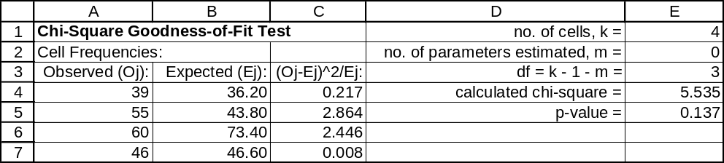

13.17 p/a/m The null and alternative hypotheses are:
H₀: Absences during any day are equally likely.
H₁: Absences during any day are not equally likely.
The degrees of freedom for this problem are 5 - 1 - 0 = 4, and the critical value of chi-square at
the 0.01 level is 13.277. Using Excel worksheet template tmchifit, the C column shows the individual components and cell E4 shows their sum, the calculated chi-square.
The calculated value (13.800) exceeds the critical value at the 0.01 level (13.277), and we reject H₀. There is evidence, at the 0.01 level, to suggest that the absences during any day are not equally likely. Alternatively, we are able to reject H₀ because p-value = 0.0080 is < α = 0.01.
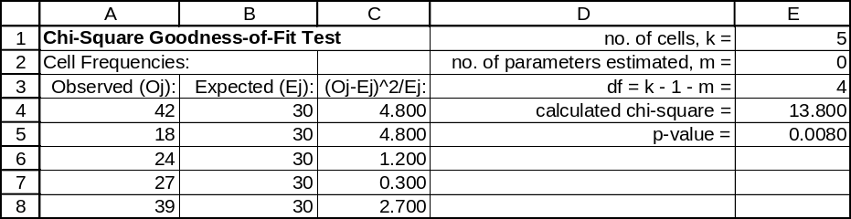

13.18 p/a/m The null and alternative hypotheses are:
H₀: Vehicle-ownership distribution in this community is like that of all U.S. households.
H₁: Vehicle-ownership distribution in this community is not like that of all U.S. households.
The degrees of freedom are 4 - 1 - 0 = 3, and the critical value of chi-square at the 0.05 level is 7.815. Using Excel worksheet template tmchifit, the C column shows the individual components and cell E4 shows their sum, the calculated chi-square. The calculated value (20.950) exceeds the critical value at the 0.05 level (7.815), and we reject H₀. There is evidence, at the 0.05 level, that the vehicle ownership in this community is not like that of all U.S. households. Alternatively, using the p-value approach, we are able to reject H₀ because p-value = 0.0001 is < α = 0.05.
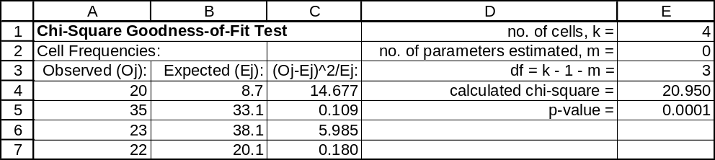

13.19 p/a/m The null and alternative hypotheses are:
H₀: The data are from a Poisson distribution with λ = 1.5
H₁: The data are not from a Poisson distribution with λ = 1.5
The degrees of freedom are 4 - 1 - 0 = 3, and the critical value of chi-square at the 0.05 level is 7.815. The expected counts are calculated with the probabilities given in the Poisson table in the appendix. Using Excel worksheet template tmchifit, the C column shows the individual components and cell E4 shows their sum, the calculated chi-square. The calculated value does not exceed the critical value at the 0.05 level, and we are unable to reject H₀. There is no evidence, at the 0.05 level, to suggest that the ownership is not Poisson-distributed with a mean of 1.5. Alternatively, using the p-value approach, we are unable to reject H₀ because p-value = 0.821 is not < α = 0.05.
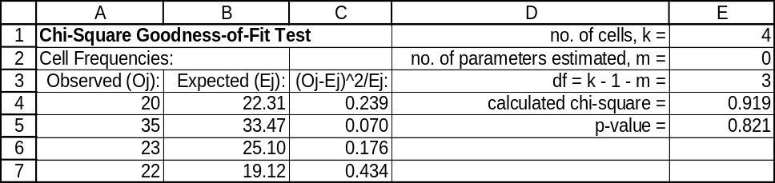

13.20 p/a/d The null and alternative hypotheses are:
H₀: The number of defectives in a batch is Poisson-distributed with a mean of λ = 2.0
H₁: The number of defectives in a batch is not Poisson distributed with a mean of λ = 2.0
The degrees of freedom for this problem are 5 - 1 - 0 = 4, and the critical value of chi-square at the 0.01 level is 13.277. The two highest categories have been combined into "4 or more". Using Excel worksheet template tmchifit, the C column shows the individual components and cell E4 shows their sum, the calculated chi-square. The calculated value does not exceed the critical value at the 0.01 level, and we are unable to reject H₀. There is no evidence, at the 0.01 level, to suggest that the number of defectives is not Poisson distributed with a mean of 2.0. Alternatively, using the p-value approach, we are unable to reject H₀ because p-value = 0.9209 is not < α = 0.01.
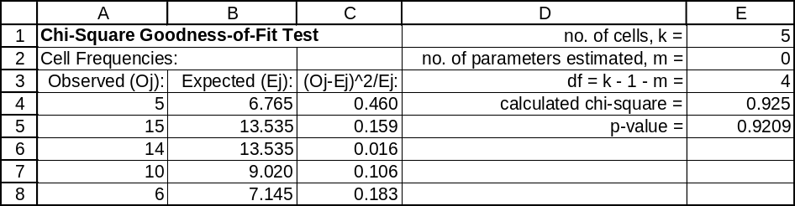

13.21 p/a/d The null and alternative hypotheses are:
H₀: The number of defectives in each batch is binomial distributed with π = 0.1
H₁: The number of defectives in each batch is not binomial distributed with π = 0.1
For this problem, d.f. = 5 - 1 - 0 = 4, and the critical value of chi-square at the 0.05 level is 9.488.
The two lowest categories have been combined into "≤ 1", and the expected counts are computed using the probabilities in the binomial table in the appendix.
Using Excel worksheet template tmchifit, the C column shows the individual components and cell E4 shows their sum, the calculated chi-square. The calculated value does not exceed the critical value at the 0.05 level, and we are unable to reject H₀. There is no evidence, at the 0.05 level, to suggest that the number of defectives is not binomial distributed with π = 0.1. Alternatively, using the p-value approach, we are unable to reject H₀ because p-value = 0.1847 is not < α = 0.05.
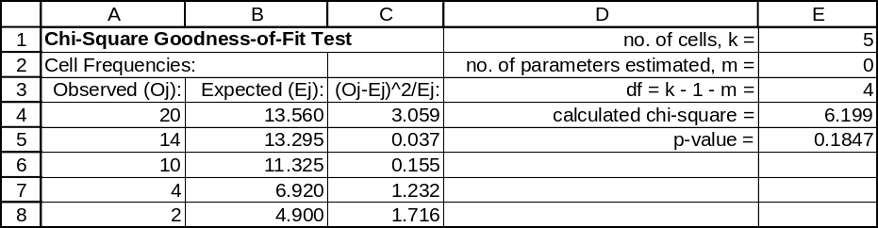

13.22 p/a/m The null and alternative hypotheses are:
H₀: The age distribution of drivers in fatal accidents in the state is like that for all U.S. drivers.
H₁: The age distribution of drivers in fatal accidents in the state is not like that for all U.S. drivers.
With d.f. = 3 - 1 - 0 = 2, the critical value of chi-square at the 0.05 level is 5.991.
Using Excel worksheet template tmchifit, the C column shows the individual components and cell E4 shows their sum, the calculated chi-square. The calculated value (13.654) exceeds the critical value, and we reject H₀. At the 0.05 level, the age distribution of drivers involved in fatal accidents within the state is not like that for all U.S. drivers. Alternatively, using the p-value approach, we are able to reject H₀ because p-value = 0.0011 is < α = 0.05.
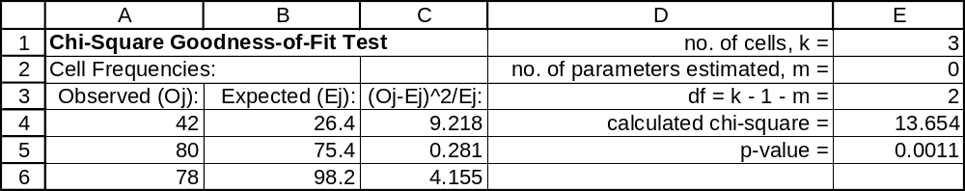

13.23 p/c/m The null and alternative hypotheses are:
H₀: The mileages are normally distributed and H₁: The mileages are not normally distributed.
For this test we will use Data Analysis Plus and its chi-squared test for normality. Note that the d.f. calculation is d.f. = k - 1 - m, or d.f. = 5 - 1 - 2 = 2. The “m” term is 2 because we have used the sample mean and standard deviation to estimate their (unknown) population counterparts.
The calculated chi-square (4.491) does not exceed the critical value (9.210 for d.f. = 2 and the 0.01 level of significance) and we do not reject H₀. Alternatively, using the p-value approach, we are not able to reject H₀ because p-value = 0.106 is not less than α = 0.01. Our conclusion is that the population could be normally distributed.
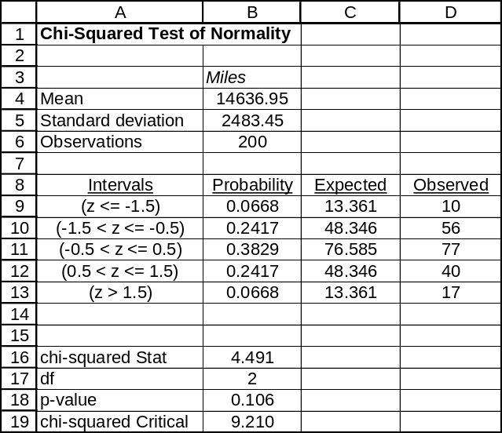

13.24 p/c/m For x = the number of defects per panel, the null and alternative hypotheses are:
H₀: x is Poisson distributed and H₁: x is not Poisson distributed. First, we use Minitab to determine the sample mean. This is 4.983 defects per panel. We then use Minitab to tally the frequency with which each x value occurs and to describe the individual and cumulative probability distributions for a Poisson distribution having a mean of 4.983.

Descriptive Statistics: defects
Variable N Mean Median TrMean StDev SE Mean
defects 300 4.983 5.000 4.952 1.744 0.101

Variable Minimum Maximum Q1 Q3
defects 0.000 10.000 4.000 6.000

Tally for Discrete Variables: defects
defects Count
0 1
1 1
2 16
3 43
4 63
5 70
6 47
7 34
8 16
9 7
10 2
N= 300

Probability Density Function Cumulative Distribution Function
Poisson with mu = 4.98300 Poisson with mu = 4.98300
x P( X = x ) x P( X <= x )
0.00 0.0069 0.00 0.0069
1.00 0.0342 1.00 0.0410
2.00 0.0851 2.00 0.1261
3.00 0.1413 3.00 0.2674
4.00 0.1761 4.00 0.4435
5.00 0.1755 5.00 0.6189
6.00 0.1457 6.00 0.7647
7.00 0.1037 7.00 0.8684
8.00 0.0646 8.00 0.9330
9.00 0.0358 9.00 0.9688
10.00 0.0178 10.00 0.9866

Next, we determine the expected frequencies for each x value. For example, the expected frequency for
x = 0 is 0.0069(300) = 2.07. The expected frequency for x ≥ 10 is (1 - 0.9688)(300) = 9.36.
We now use Excel worksheet template tmchifit. Note that the d.f. value is calculated as
d.f. = k - 1 - m, or d.f. = 5 - 1 - 1 = 3. The “m” term is 1 because we have used the sample mean (4.983) to estimate its (unknown) population counterpart. The calculated chi-square (28.347) exceeds the critical value (7.815 for df = 3 and the 0.05 level of significance) and we reject H₀. Alternatively, using the
p-value approach, we are able to reject H₀ because p-value = 0.001 is less than α = 0.05.
We conclude that the population is not Poisson distributed.
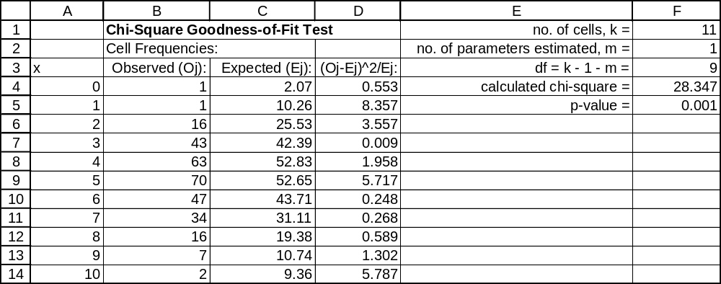

13.25 p/c/m For x = the number of defects per panel, the null and alternative hypotheses are:
H₀: x is normally distributed and H₁: x is not normally distributed.
For this test we will use Data Analysis Plus and its chi-squared test for normality. Note that the d.f. calculation is d.f. = k - 1 - m, or d.f. = 6 - 1 - 2 = 3. The “m” term is 2 because we have used the sample mean and standard deviation to estimate their (unknown) population counterparts.
The calculated chi-square (31.585) exceeds the critical value (7.815 for d.f. = 3 and the 0.05 level of significance) and we reject H₀. Alternatively, using the p-value approach, we are able to reject H₀ because p-value = 0.0000 (to four decimal places) is less than α = 0.05. Our conclusion is that the population could not be normally distributed.
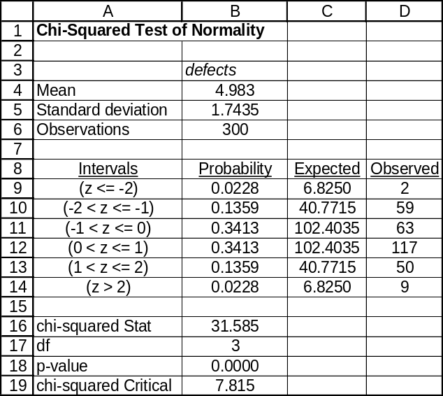

13.26 p/c/m The null and alternative hypotheses are:
H₀: the balances are normally distributed and H₁: the balances are not normally distributed.
For this test we will use Data Analysis Plus and its chi-squared test for normality. The calculated
chi-square (1.560) does not exceed the critical value (6.251 for d.f. = 3 and the 0.10 level of significance) and we do not reject H₀. Alternatively, using the p-value approach, we are not able to reject H₀ because p-value = 0.6684 is not less than α = 0.10. Our conclusion is that the population could be normally distributed.
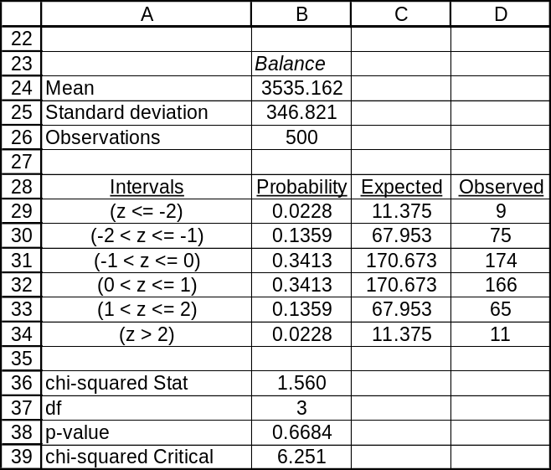

13.27 d/p/e The chi-square distribution is continuous, while the counts on which the test statistic is based are discrete. The approximation will be unsatisfactory whenever one or more of the expected frequencies is small (less than five).

13.28 d/p/e The degrees of freedom value for the test of independence is (r - 1)*(k - 1), where r is the number of rows in the table, and k is the number of columns in the table.

13.29 c/p/e The degrees of freedom are calculated as described in exercise 13.28. The d.f. values are:
a. 2*3 = 6 b. 1*2 = 2 c. 3*4 = 12 d. 4*2 = 8 e. 2*6 = 12 f. 2*2 = 4

13.30 c/p/e The critical values of chi-square are:
a. 7.815 b. 15.086 c. 4.605 d. 11.143

13.31 c/p/e The critical values of chi-square are:
a. 12.833 b. 15.507 c. 16.812 d. 7.779

13.32 c/p/e The d.f. value will be (2 - 1)(3 - 1), or d.f. = 2. For a test at the 0.025 level, the critical value of chi-square will be 7.378. For a test at the 0.05 level, the critical value of chi-square will be 5.991.

13.33 c/p/m The null and alternative hypotheses are:
H₀: Age category is independent of type of greeting received
H₁: Age category is not independent of type of greeting received
With d.f. = (3 - 1)(3 - 1) = 4, the critical value of chi-square at the 0.025 level is 11.143. We can do this type of problem with a calculator or with Data Analysis Plus, but we will use Minitab.
The printout below shows the actual frequencies, the expected frequencies, the cell contributions to the calculated chi-square, and the p-value:

Chi-Square Test: C1, C2, C3

Expected counts are printed below observed counts
Chi-Square contributions are printed below expected counts

C1 C2 C3 Total
1 16 12 5 33
9.90 15.18 7.92
3.759 0.666 1.077

2 8 20 6 34
10.20 15.64 8.16
0.475 1.215 0.572

3 6 14 13 33
9.90 15.18 7.92
1.536 0.092 3.258

Total 30 46 24 100

Chi-Sq = 12.650, DF = 4, P-Value = 0.013

The calculated chi-square (12.650) exceeds the critical value (11.143) at the 0.025 level, so we reject H₀. Using the table in the appendix, we can determine that the p-value for this problem is between 0.025 and 0.01. Alternatively, we reject H₀ because p-value = 0.013 is less than α = 0.025 level of significance for the test. At this level, age category is not independent of the type of greeting received.

13.34 c/p/m The null and alternative hypotheses are:
H₀: Number of telephones owned is independent of the number of persons in the household
H₁: Number of telephones owned is not independent of the number of persons in the household
With d.f. = (3 - 1)(3 - 1) = 4, the critical value of chi-square at the 0.05 level is 9.488. We can do this type of problem with a calculator or with Data Analysis Plus, but we will use Minitab.
The printout below shows the actual frequencies, the expected frequencies, the cell contributions to the calculated chi-square, and the p-value:

Chi-Square Test: C1, C2, C3

Expected counts are printed below observed counts
Chi-Square contributions are printed below expected counts

C1 C2 C3 Total
1 49 18 13 80
40.00 23.20 16.80
2.025 1.166 0.860

2 40 27 21 88
44.00 25.52 18.48
0.364 0.086 0.344

3 11 13 8 32
16.00 9.28 6.72
1.563 1.491 0.244

Total 100 58 42 200

Chi-Sq = 8.141, DF = 4, P-Value = 0.087
The calculated chi-square (8.141) does not exceed the critical value (9.488) at the 0.05 level, so we do not reject H₀. Using the table in the appendix, we can determine that the p-value for this problem is between 0.05 and 0.10. Alternatively, we are unable to reject H₀ because p-value = 0.087 is not less than α = 0.05 level of significance for the test. At this level, the number of telephones is independent of the number of persons in the household.

13.35 c/p/m The null and alternative hypotheses are:
H₀: Import/Domestic ownership is independent of magazine preference
H₁: Import/Domestic ownership is not independent of magazine preference
With d.f. = (3 - 1)(2 - 1) = 2, the critical value of chi-square at the 0.05 level is 5.991.
We will use Excel worksheet template tmchivar. The printout below shows the actual frequencies,
the expected frequencies, the calculated chi-square, and the p-value. The calculated chi-square exceeds the critical value, and we reject H₀. Using the table in the appendix, we can determine that the p-value
for this problem is between 0.05 and 0.025.
Alternatively, because p-value = 0.043 is < α = 0.05 level of significance for the test, we reject H₀.
At this level, Import/Domestic ownership is not independent of magazine preference.
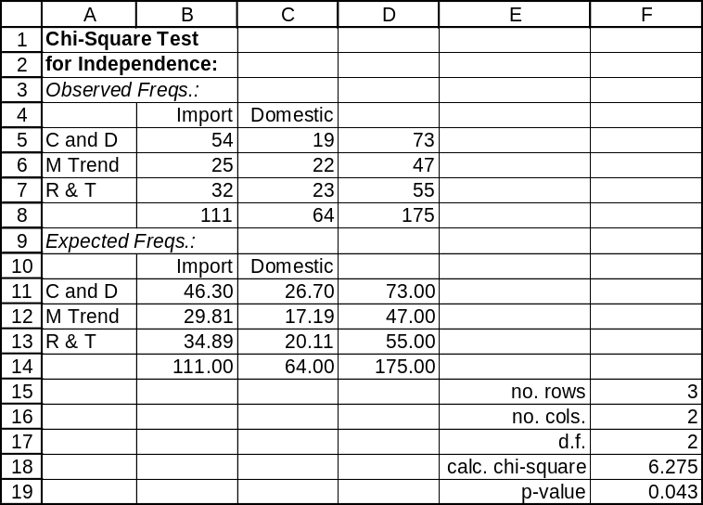

Using Data Analysis Plus, we obtain the comparable results shown below:
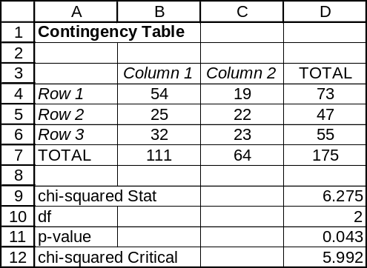

13.36 p/a/m The null and alternative hypotheses are:
H₀: Age and prescription form are independent
H₁: Age and prescription form are not independent
With d.f. = (3 - 1)(2 - 1) = 2, the critical value of chi-square at the 0.025 level is 7.378. We will use Excel worksheet template tmchivar. The printout below shows the actual frequencies, the expected frequencies, the calculated chi-square, and the p-value. The calculated chi-square does not exceed the critical value, and we do not reject H₀. Using the table in the appendix, we can determine that the p-value for this problem is between 0.05 and 0.10.
Alternatively, because p-value = 0.067 is not < α = 0.025 level of significance for the test, we do not reject H₀. At this level, age and prescription form are independent.
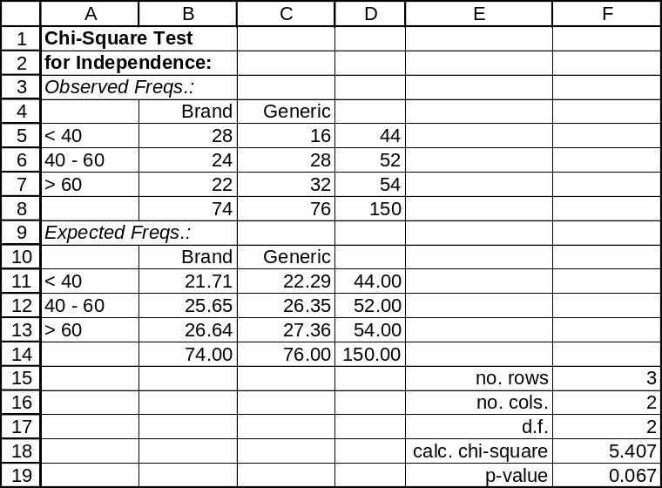

13.37 p/a/m The null and alternative hypotheses are:
H₀: Bag preference and level of education are independent
H₁: Bag preference and level of education are not independent
Categories have been combined so each expected frequency will be ≥ 5. With d.f. = (3 - 1)(3 - 1) = 4,
the critical value of chi-square at the 0.01 level is 13.277. We will use Excel worksheet template tmchivar. The printout below shows the actual frequencies, the expected frequencies, the calculated chi-square, and the p-value. The calculated chi-square exceeds the critical value, and we reject H₀.
Using the table in the appendix, we can determine that the p-value for this problem is less than 0.01.
Alternatively, because p-value = 0.004 is < α = 0.01 level of significance for the test, we reject H₀.
At this level, bag preference and education level are not independent.
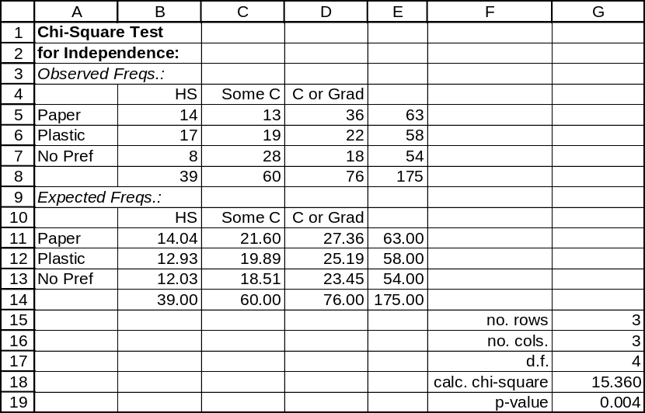

Using Data Analysis Plus, and combining the third and fourth education-level categories, we obtain the comparable results shown below:
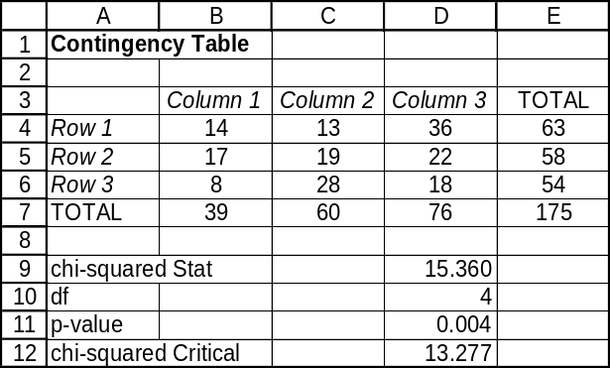

13.38 c/a/m The null and alternative hypotheses are:
H₀: Inspectors and production quality are independent
H₁: Inspectors and production quality are not independent
With d.f. = (3 - 1)(3 - 1) = 4, the critical value of chi-square at the 0.10 level is 7.779. We will use Excel worksheet template tmchivar. The printout below includes the actual frequencies, the expected frequencies, the calculated chi-square, and the p-value. The calculated chi-square does not exceed the critical value, and we do not reject H₀. Using the table in the appendix, we can determine that the p-value for this problem is between 0.90 and 0.10.
Alternatively, because p-value = 0.118 is not < α = 0.10 level of significance for the test,
we do not reject H₀. At this level, inspectors and production quality are independent.
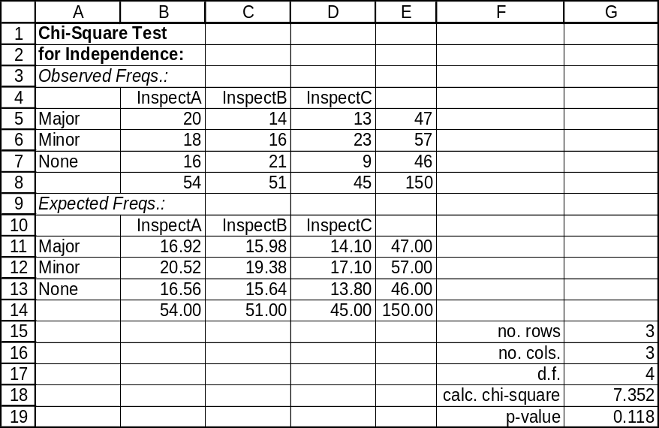

13.39 p/a/m The null and alternative hypotheses are:
H₀: The quarter of the game is independent of the free throw result
H₁: The quarter of the game is not independent of the free throw result
With d.f. = (3 - 1)(4 - 1) = 6, the critical value of chi-square at the 0.025 level is 14.449. We will use Excel worksheet template tmchivar. The printout below includes the actual frequencies, the expected frequencies, the calculated chi-square, and the p-value. The calculated chi-square does not exceed the critical value, and we do not reject H₀.
Alternatively, because p-value = 0.067 is not < α = 0.025 level of significance for the test, we do not reject H₀. At this level, the quarter of the game is independent of the free throw result.
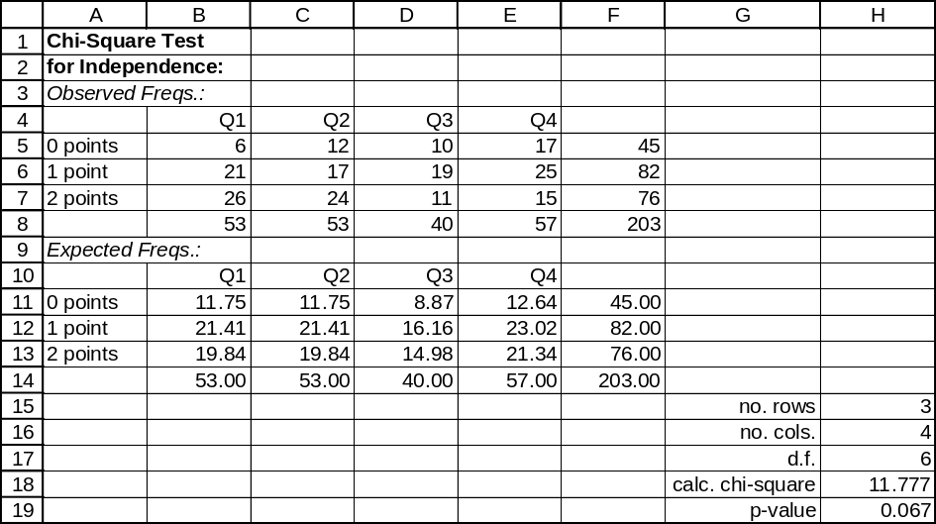

13.40 p/c/m The null and alternative hypotheses are:
H₀: Weather reporter preference is independent of level of education of viewer
H₁: Weather reporter preference is not independent of level of education of viewer
The Minitab printout below includes the actual frequencies, the calculated chi-square, and the
p-value. Because p-value = 0.249 is not < α = 0.05 level of significance for the test, we do not reject H₀. At this level, weather reporter preference is independent of the viewer's education level.

Tabulated Statistics: EdLevel, RepPref

Rows: EdLevel Columns: RepPref

1 2 3 All

1 15 19 22 56
2 103 87 95 285
3 65 82 56 203
4 29 36 34 99
All 212 224 207 643

Chi-Square = 7.850, DF = 6, P-Value = 0.249

Cell Contents -- Count

13.41 p/c/m The null and alternative hypotheses are:
H₀: Type of return is independent of the type of IRS examiner assigned
H₁: Type of return is not independent of the type of IRS examiner assigned
The Minitab printout below includes the actual frequencies, the calculated chi-square, and the
p-value. Because p-value = 0.037 is less than α = 0.05 level of significance for the test, we reject H₀.
At this level, type of return is not independent of type of IRS examiner assigned.

Tabulated Statistics: Income, Examiner

Rows: Income Columns: Examiner

1 2 3 All

1 35 112 32 179
2 33 74 29 136
3 76 193 35 304
4 58 107 36 201
All 202 486 132 820

Chi-Square = 13.411, DF = 6, P-Value = 0.037

Cell Contents -- Count

13.42 c/a/m The null and alternative hypotheses are:
H₀: The population proportions are equal
H₁: At least one population proportion differs
This test can be performed using Minitab. First, we must compute the observed counts for each cell. These are simply the proportion * n and (1 - the proportion) * n. The degrees of freedom for this test are (2 - 1)(3 - 1) = 2, and the critical value of chi-square at the 0.05 level is 5.991. Since the calculated value is less than the critical value, we do not reject H₀. At this level, there is no evidence to suggest that at least one population proportion differs from the others. Alternatively, we fail to reject H₀ because p-value = 0.321 is not < α = 0.05 level of significance for the test.

Chi-Square Test: C1, C2, C3

Expected counts are printed below observed counts
Chi-Square contributions are printed below expected counts

C1 C2 C3 Total
1 20 30 36 86
20.48 24.57 40.95
0.011 1.199 0.599

2 80 90 164 334
79.52 95.43 159.05
0.003 0.309 0.154

Total 100 120 200 420

Chi-Sq = 2.275, DF = 2, P-Value = 0.321

13.43 c/a/m The null and alternative hypotheses are:
H₀: The population proportions are equal
H₁: At least one population proportion differs
This test can be performed using Minitab. First, however, we must compute the observed counts for each cell. These are simply the proportion * n and (1 - the proportion) * n. The degrees of freedom for this test are (2 - 1)(4 - 1) = 3, and the critical value of chi-square at the 0.025 level is 9.348. Since the calculated value is less than the critical value, we do not reject H₀. At this level, there is no evidence to suggest that the population proportions are not equal. Alternatively, we fail to reject H₀ because p-value = 0.420 is not < α = 0.025 level of significance for the test.

Chi-Square Test: C1, C2, C3, C4

Expected counts are printed below observed counts
Chi-Square contributions are printed below expected counts

C1 C2 C3 C4 Total
1 45 16 35 13 109
38.93 20.76 36.33 12.98
0.947 1.092 0.049 0.000

2 105 64 105 37 311
111.07 59.24 103.67 37.02
0.332 0.383 0.017 0.000

Total 150 80 140 50 420

Chi-Sq = 2.820, DF = 3, P-Value = 0.420

13.44 c/a/m The null and alternative hypotheses are:
H₀: The population proportions are equal
H₁: At least one population proportion differs
We will use Data Analysis Plus for this test. The degrees of freedom for this test are (2 - 1)(3 - 1) = 2 and the critical value of chi-square at the 0.05 level is listed in our chi-square table as 5.991. Since the calculated value does not exceed the critical value, we do not reject H₀. At this level, the population proportions could be equal. Alternatively, we do not reject H₀ because p-value = 0.304 is not < α = 0.05 level of significance for the test.
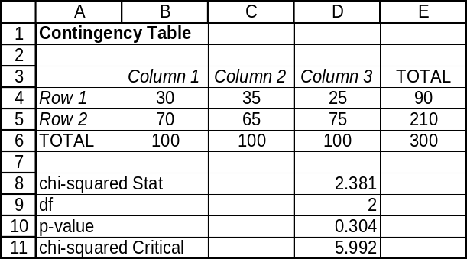

13.45 p/a/m The null and alternative hypotheses are:
H₀: The population proportions are equal
H₁: At least one population proportion differs
We will use Data Analysis Plus for this test. The degrees of freedom for this test are (2 - 1)(3 - 1) = 2 and the critical value of chi-square at the 0.01 level is listed in our chi-square table and shown below as 9.210. Since the calculated value does not exceed the critical value, we do not reject H₀.
At this level, the population proportions could be equal. Alternatively, we do not reject H₀ because
p-value = 0.094 is not < α = 0.01 level of significance for the test.
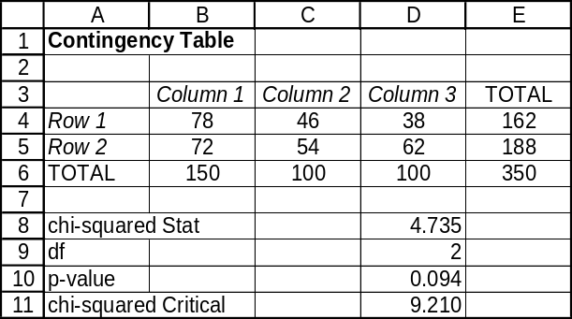

13.46 p/a/m The null and alternative hypotheses are:
H₀: The population proportions are equal for all of the cities
H₁: At least one population proportion differs
This test can be performed using Minitab. First, however, we must compute the observed counts for each cell. These are simply the proportion*n and (1 - the proportion)*n. The degrees of freedom for this test are (2 - 1)(3 - 1) = 2 and the critical value of chi-square at the 0.01 level is 9.210. Since the calculated value exceeds the critical value, we reject H₀. At this level, at least one population proportion differs from the others. Alternatively, we reject H₀ because p-value = 0.000 is < α = 0.01 level of significance for the test.

Chi-Square Test: C1, C2, C3

Expected counts are printed below observed counts
Chi-Square contributions are printed below expected counts

C1 C2 C3 Total
1 150 80 32 262
87.33 87.33 87.33
44.967 0.616 35.059

2 50 120 168 338
112.67 112.67 112.67
34.856 0.477 27.176

Total 200 200 200 600

Chi-Sq = 143.150, DF = 2, P-Value = 0.000

13.47 p/a/m The null and alternative hypotheses are:
H₀: The population proportions heating with electricity are equal for these years
H₁: At least one population proportion differs
We will use Data Analysis Plus for this test. The degrees of freedom for this test are (2 - 1)(3 - 1) = 2 and the critical value of chi-square at the 0.05 level is listed in our chi-square table as 5.991. Since the calculated value exceeds the critical value, we reject H₀. At this level, at least one population proportion differs from the others. Alternatively, we reject H₀ because p-value = 0.000 is < α = 0.05 level of significance for the test.
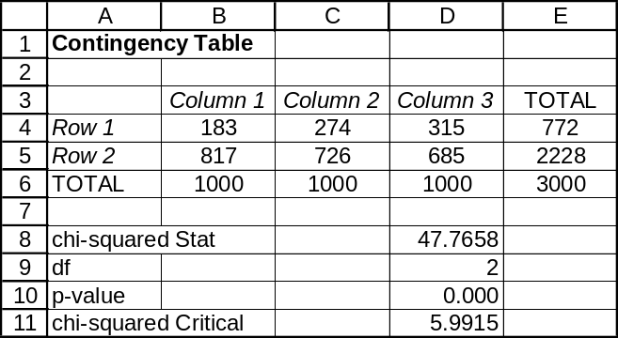

13.48 p/a/m The null and alternative hypotheses are:
H₀: The population proportions are equal for the occupation groups
H₁: The population proportions are not equal for the occupation groups
We will use Minitab. The degrees of freedom for this test are (2 - 1)(3 - 1) = 2 and the critical value of chi-square at the 0.05 level is 5.991. Since the calculated value does not exceed the critical value, we do not reject H₀. At this level, the population proportions who seldom or never eat cottage cheese could be the same. Alternatively, we do not reject H₀ because p-value = 0.090 is not < α = 0.05 level of significance for the test.

Chi-Square Test: C1, C2, C3

Expected counts are printed below observed counts
Chi-Square contributions are printed below expected counts

C1 C2 C3 Total
1 326 220 522 1068
347.96 203.29 516.75
1.386 1.374 0.053

2 511 269 721 1501
489.04 285.71 726.25
0.986 0.977 0.038

Total 837 489 1243 2569

Chi-Sq = 4.815, DF = 2, P-Value = 0.090

13.49 p/c/m The null and alternative hypotheses are:
H₀: The population percentages buying snacks are the same for all three movies
H₁: The population percentages buying snacks are not the same for all three movies
In the Minitab printout below, the p-value is 0.047. Because p-value = 0.047 is not less than the α = 0.025 level of significance for the test, we do not reject H₀. At this level, the population percentages buying snacks could be the same for all three movies.

Tabulated Statistics: SnackCat, Movie

Rows: SnackCat Columns: Movie
1 2 3 All
1 28 35 24 87
2 22 65 36 123
All 50 100 60 210

Chi-Square = 6.129, DF = 2, P-Value = 0.047

Cell Contents --
Count

13.50 p/c/m The null and alternative hypotheses are:
H₀: The calculators are equally easy to use
H₁: The calculators are not equally easy to use
In the Minitab printout below, the p-value is 0.002. Because p-value = 0.002 is less than the α = 0.01 level of significance for the test, we reject H₀. At this level, we conclude that the calculators are not equally easy to use.

Tabulated Statistics: EaseCat, CalcType
Rows: EaseCat Columns: CalcType

1 2 3 4 All
1 16 10 8 4 38
2 4 10 12 16 42
All 20 20 20 20 80

Chi-Square = 15.038, DF = 3, P-Value = 0.002

Cell Contents --
Count

13.51 d/p/e The assumption of normality is required because the test for a population variance relies on transforming the equation for the sampling distribution of chi-square. This distribution is based on random samples from a normal population.

13.52 d/p/m The confidence interval for the population variance cannot be expressed as s² plus or minus a term because the chi-square distribution is asymmetric.

13.53 c/a/d
The lower limit of the 95% confidence interval is: 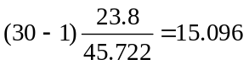
The upper limit of the 95% confidence interval is: 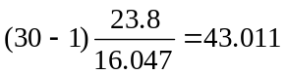
Therefore, the 95% confidence interval is (15.096, 43.011).

13.54 c/a/d
The lower limit of the 98% confidence interval is: 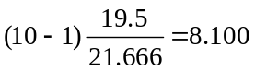
The upper limit of the 98% confidence interval is: 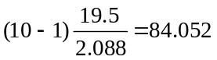
Therefore, the 98% confidence interval is (8.100, 84.052).

13.55 c/a/d Using the Estimators workbook that acompanies Data Analysis Plus, we obtain the 95% confidence interval for the population variance as (2.620, 9.664).
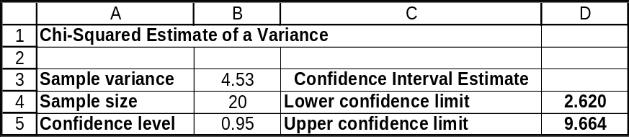

13.56 p/a/d In terms of the population variance, the null and alternative hypotheses are:
H₀: σ² ≤ 1.44 and H₁: σ² > 1.44
Based on the summary statistics in the exercise, we can use the Test Statistics workbook that accompanies Data Analysis Plus. This procedure requires that we square the hypothesized and sample standard deviations (1.20 and 1.32) to obtain the variances (1.44 and 1.7424). Although the sample variance exceeds the hypothesized population variance, the p-value in this right-tail test is 0.2378 and this is not less than the 0.05 significance level at which the test is being conducted. Thus, we do not reject H₀. The pharmaceutical company has no evidence to indicate that the population variance is greater than 1.20², or 1.44.
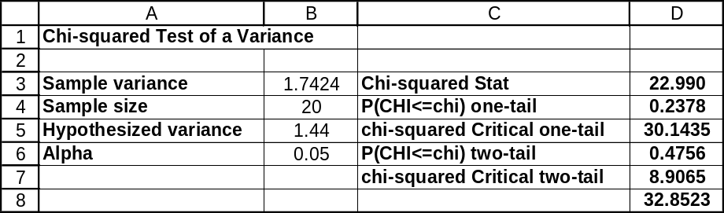

13.57 p/a/d The sample variance is s² = 0.18² = 0.0324.
The lower limit for the 90% confidence interval for the variance is: 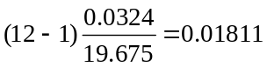
The upper limit for the 90% confidence interval for the variance is: 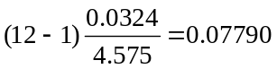

Thus, the 90% confidence interval for the variance is (0.01811, 0.07790).
Taking the square root of the variance to determine the standard deviation yields a 90% confidence interval of (0.1346, 0.2791) for σ.

Given the summary information in the exercise, we can also use the Estimators workbook that accompanies Data Analysis Plus. The results, expressed in terms of the variance limits, are shown below:
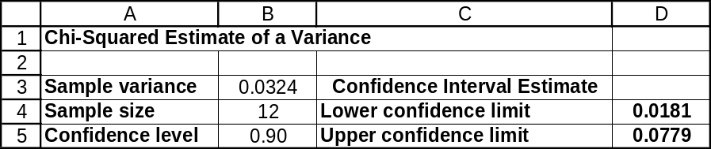

13.58 p/a/d The sample variance is s² = 01.4² = 1.96.
The lower limit for the 95% confidence interval for the variance is: 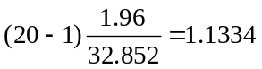
The upper limit for the 95% confidence interval for the variance is: 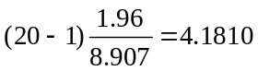

Taking the square roots of these variance limits, the 95% confidence interval for the standard deviation is (1.0646, 2.0447).

Given the summary information in the exercise, we can also use the Estimators workbook that accompanies Data Analysis Plus. The results, expressed in terms of the variance limits, are shown below:
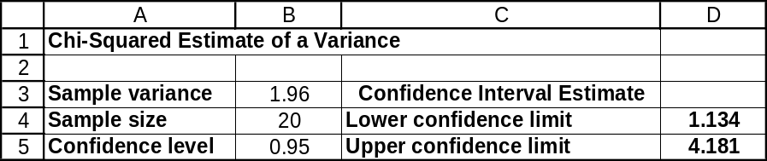

13.59 c/a/d The degrees of freedom for this problem are 30 - 1 = 29. This is a two-tail test; we will reject the null hypothesis if the calculated value is <16.047 or the calculated value > 45.722. The calculated value is 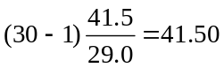. Since the calculated value falls between the critical values, we fail to reject the null hypothesis. There is no evidence, at the 0.05 level, that σ² ≠ 29.0.
Given the summary information in the exercise, we can also use the Test Statistics workbook that accompanies Data Analysis Plus. The p-value for this two-tail test (0.1245) is not less than the 0.05 level of significance for the test, and we are not able to reject the null hypothesis that the population variance is 29.0. (In this solution, note that the calculated chi-square and the sample variance just happen to have the same numerical value.)
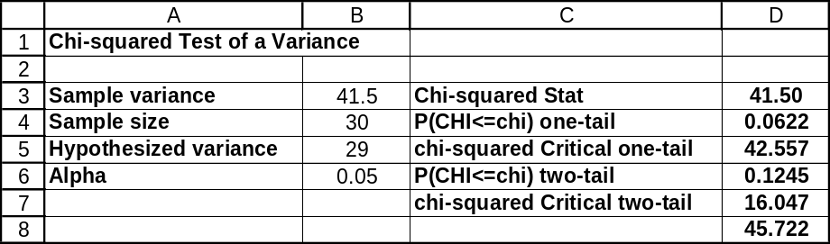

13.60 c/a/d The degrees of freedom for this problem are 12 - 1 = 11. This is an upper-tail test. The critical value of chi-square at the 0.025 level is 21.920. The calculated value is 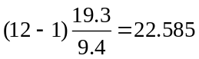. Since the calculated value exceeds the critical value, we reject the null hypothesis. There is evidence, at the 0.025 level, to suggest that σ² > 9.4.
Given the summary information in the exercise, we can also use the Test Statistics workbook that accompanies Data Analysis Plus. The p-value for this one-tail test (0.0202) is less than the 0.025 level of significance for the test, so we reject the null hypothesis that the population variance is no more than 9.4.
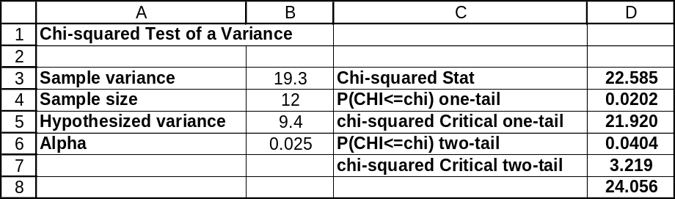

13.61 c/a/d In terms of the population variance, the null and alternative hypotheses are:
H₀: σ² ≤ 0.000009 and H₁: σ² > 0.000009
The degrees of freedom for this problem are 25 - 1 = 24. This is an upper tail test. The critical value of chi-square at the 0.025 level is 39.364. The calculated chi-square is 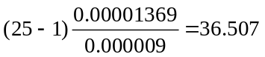.
Since the calculated value is less than the critical value, we fail to reject the null hypothesis. There is no evidence, at the 0.025 level, to suggest that the population variance is greater than 0.000009 (or that the population standard deviation is greater than 0.003 inches). Using the chi-square table in the appendix, the most accurate statement that we can make about the p-value for this problem is that it is between 0.05 and 0.025.
Given the summary information in the exercise, we can also use the Test Statistics workbook that accompanies Data Analysis Plus. The p-value for this one-tail test (0.0490) is not less than the 0.025 level of significance for the test, and we are not able to reject the null hypothesis.
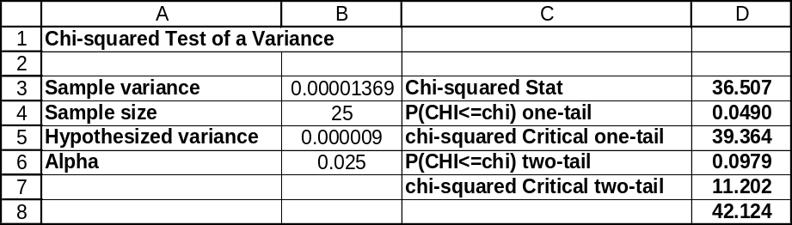

13.62 p/c/d In terms of the population variance, the null and alternative hypotheses are:
H₀: σ² ≥ 0.0784 and H₁: σ² < 0.0784
Using Excel and Data Analysis Plus and the printout shown below, the calculated value of 37.0408 is less than the critical value (43.1880) and we reject the null hypothesis. Alternatively, we reject the null hypothesis because the p-value for this one-tail test is 0.0086, and this is less than the 0.05 level of significance being used to reach a conclusion. There is evidence to suggest that the variance is reduced using the new method.
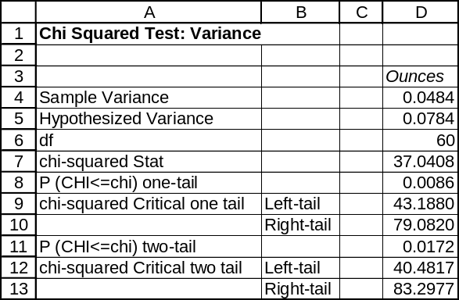

13.63 p/c/d Using Excel and Data Analysis Plus, the 98% confidence interval for the variance is shown in the printout below. We are 98% confident that the population variance is between 0.0329 and 0.0775.
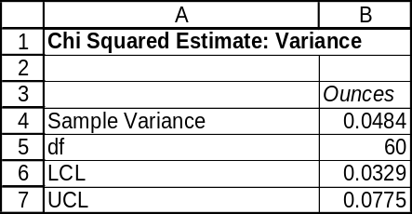

CHAPTER EXERCISES
13.64 p/a/m The null and alternative hypotheses are:
H₀: Age is independent of the length of absence
H₁: Age is not independent of the length of absence
With d.f. = (3 - 1)(4 - 1) = 6, the critical value of chi-square at the 0.01 level is 16.812.
We will use Data Analysis Plus for the solution. The calculated chi-square does not exceed the critical value, and we do not reject H₀. At this level, age is independent of the length of absence. Alternatively, because p-value = 0.016 is not < α = 0.01 level of significance for the test, we do not reject H₀.
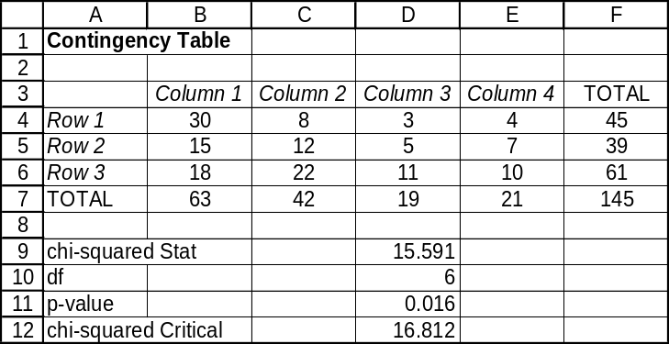

13.65 p/a/d
The null and alternative hypotheses are:
H₀: The data are drawn from a population that is Poisson with λ = 1.4
H₁: The data are not drawn from a population that is Poisson with λ = 1.4
The degrees of freedom for this problem are 4 - 1 - 0 = 3, and the critical value of chi-square at the 0.05 level is 7.815. The final four categories had to be combined to achieve a high enough expected cell count. We will use Excel worksheet template tmchifit. The calculated value does not exceed the critical value at the 0.05 level, and we are not able to reject H₀. At this level, there is no evidence to suggest that the data are not drawn from a population that follows a Poisson distribution with λ = 1.4. Alternatively, using the p-value approach, we are unable to reject H₀ because p-value = 0.406 is not < α = 0.05 level of significance for the test.
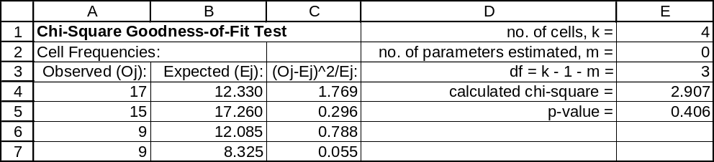

13.66 p/a/m The null and alternative hypotheses are:
H₀: The distribution of these types of robberies in this community is similar to that for the nation as a whole
H₁: The distribution of these types of robberies in this community is not similar to that for the nation as a whole
The degrees of freedom for this problem are 4 - 1 - 0 = 3, and the critical value of chi-square at the 0.05 level is 7.815. We will use Excel worksheet template tmchifit. The calculated value does not exceed the critical value at the 0.05 level, and we do not reject H₀. At this level, it appears that the distribution of these types of robberies in this community could be similar to that for the nation as a whole. Alternatively, using the p-value approach, we do not reject H₀ because p-value = 0.602 is not less than the α = 0.05 level of significance for the test.
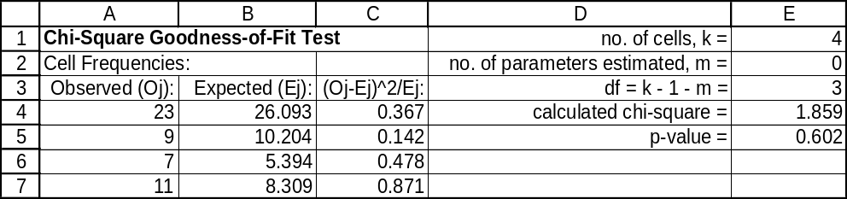

13.67 p/a/d The null and alternative hypotheses are:
H₀: The data are drawn from a population that is Poisson-distributed
H₁: The data are not drawn from a population that is Poisson-distributed
The degrees of freedom for this problem are 5 - 1 - 1 = 3. The sample mean (180/100 = 1.8) is used to estimate the population mean (λ). The critical value of chi-square at the 0.05 level is 7.815.
The upper two categories are combined so that no expected cell is < 5. We will use Excel worksheet template tmchifit. The calculated value exceeds the critical value at the 0.05 level, and we reject H₀.
At this level, there is evidence to suggest that the data are not drawn from a population that follows a Poisson distribution. Using the p-value approach, we reject H₀ because p-value = 0.0264 is < α = 0.05 level of significance for the test.
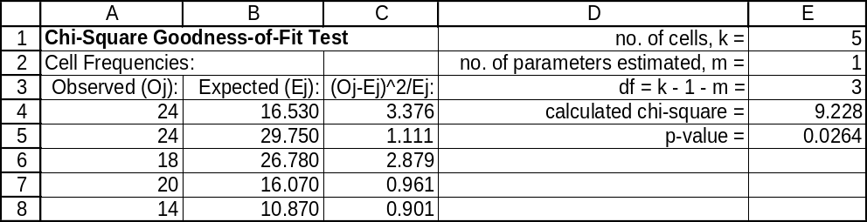

13.68 p/a/m The null and alternative hypotheses are:
H₀: The digits are uniformly distributed and H₁: The digits are not uniformly distributed
The degrees of freedom for this problem are 10 - 1 - 0 = 9, and the critical value of chi-square at the 0.10 level is 14.684. We will use Excel worksheet template tmchifit. The calculated value does not exceed the critical value at the 0.10 level, and we do not reject H₀. At this level, there is no evidence to suggest that the digits have not been drawn from a discrete uniform distribution. Alternatively, using the p-value approach, we do not reject H₀ because p-value = 0.6787 is not < α = 0.10 level of significance for the test.
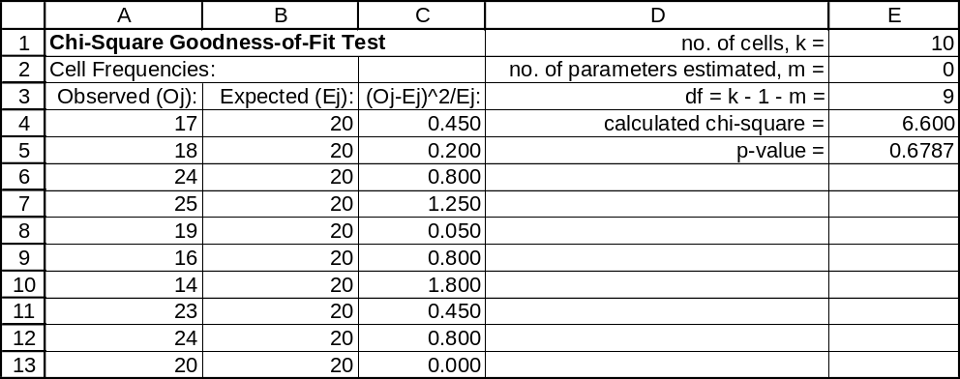

13.69 p/a/d The null and alternative hypotheses are:
H₀: The distribution of regions of birth for foreign-born persons in this city follows the national distribution.
H₁: The distribution of regions of birth for foreign-born persons in this city differs from the national distribution.
The degrees of freedom for this problem are 6 - 1 - 0 = 5, and the critical value of chi-square at the 0.05 level is 11.070. We will use Excel worksheet template tmchifit. The calculated value does not exceed the critical value at the 0.05 level, and we do not reject H₀. At this level, there is no evidence to suggest that the birth-origin distribution for foreign-born persons in this city differs from that of the nation as a whole. Using the p-value approach, we do not reject H₀ because p-value = 0.115 is not < α = 0.05 level of significance for the test.
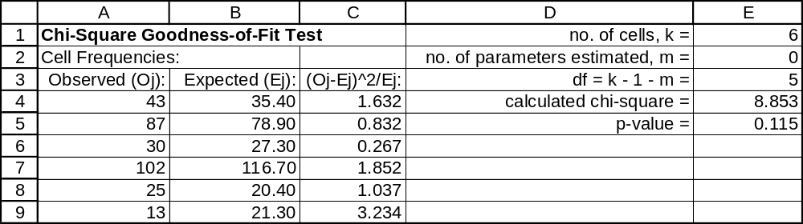

13.70 p/a/m The null and alternative hypotheses are:
H₀: The local station's distribution of contributions is similar to the national distribution
H₁: The local station's distribution of contributions is not similar to the national distribution
The degrees of freedom for this problem are 3 - 1 - 0 = 2, and the critical value of chi-square at the 0.05 level is 5.991. We will use Excel worksheet template tmchifit. The calculated value does not exceed the critical value at the 0.05 level, and we do not reject H₀. At this level, there is no evidence to suggest that the local station's distribution of contributions is not similar to the national distribution. Alternatively, using the p-value approach, we do not reject H₀ because p-value = 0.0646 is not < α = 0.05 level of significance for the test.
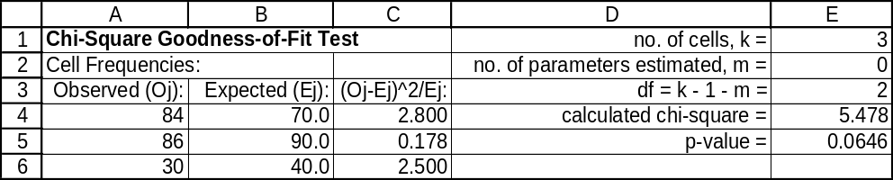

13.71 p/a/m The null and alternative hypotheses are:
H₀: The employees have been selected at random
H₁: The employees have not been selected at random
Note that a random selection should tend to follow the overall distribution of employees. The degrees of freedom for this problem are 3 - 1 - 0 = 2, and the critical value of chi-square at the 0.025 level is 7.378. We will use Excel worksheet template tmchifit. The calculated value does not exceed the critical value at the 0.025 level, and we do not reject H₀. At this level, we conclude that the employees could have been selected at random. Using the table in the appendix, the most accurate statement that we can make about the p-value for this problem is that it is between 0.10 and 0.05. Alternatively, using Excel and the p-value approach, we do not reject H₀ because p-value = 0.064 is not < α = 0.025 level of significance for the test.
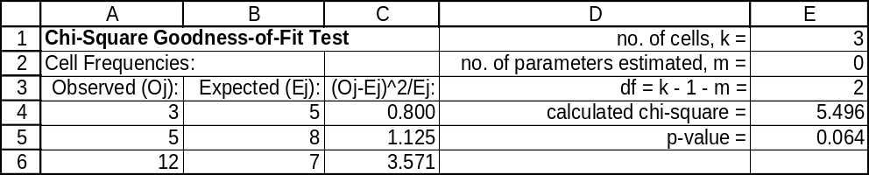

13.72 p/a/m The null and alternative hypotheses are:
H₀: The relative movement of vehicles is independent of accident setting
H₁: The relative movement of vehicles is not independent of accident setting
With d.f. = (2 - 1)(3 - 1) = 2, the critical value of chi-square at the 0.01 level is 9.210. We will use Minitab. The calculated chi-square does not exceed the critical value, and we do not reject H₀. At this level, relative movement of vehicles is independent of accident setting. Alternatively, because
p-value = 0.153 is not < α = 0.01 level of significance for the test, we do not reject H₀.

Chi-Square Test: C1, C2, C3

Expected counts are printed below observed counts
Chi-Square contributions are printed below expected counts

C1 C2 C3 Total
1 40 30 72 142
37.33 34.08 70.59
0.192 0.488 0.028

2 6 12 15 33
8.67 7.92 16.41
0.824 2.102 0.120

Total 46 42 87 175

Chi-Sq = 3.755, DF = 2, P-Value = 0.153

13.73 p/a/m The null and alternative hypotheses are:
H₀: The constituency of the marching band is similar to that for the entire university
H₁: The constituency of the marching band is not similar to that for the entire university
The degrees of freedom for this problem are 4 - 1 - 0 = 3, and the critical value of chi-square at the 0.05 level is 7.815. We will use Excel worksheet template tmchifit. The calculated value does not exceed the critical value at the 0.05 level, and we do not reject H₀. At this level, we conclude that the constituency of the marching band could be similar to that for the entire university. Using the table in the appendix, the most accurate statement that we can make about the p-value for this problem is that it is between 0.10 and 0.05. Alternatively, using Excel and the p-value approach, we do not reject H₀ because p-value = 0.070 is not < α = 0.05 level of significance for the test.
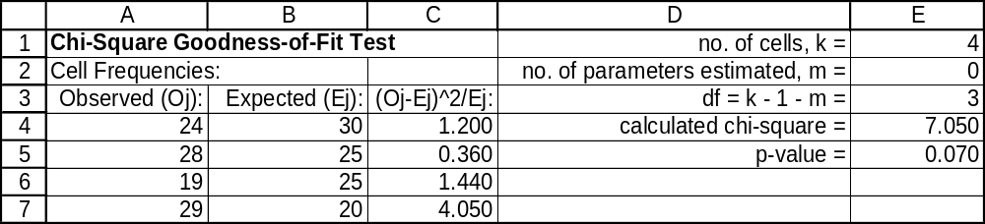

13.74 p/a/m The null and alternative hypotheses are:
H₀: The three techniques are equally effective
H₁: The three techniques are not equally effective
With d.f. = (2 - 1)(3 - 1) = 2, the critical value of chi-square at the 0.05 level is 5.991. We will use Excel worksheet template tmchipro. The calculated chi-square does not exceed the critical value, and we do not reject H₀. At this level, the three techniques could be equally effective. Alternatively, because p-value = 0.400 is not < α = 0.05 level of significance for the test, we do not reject H₀.
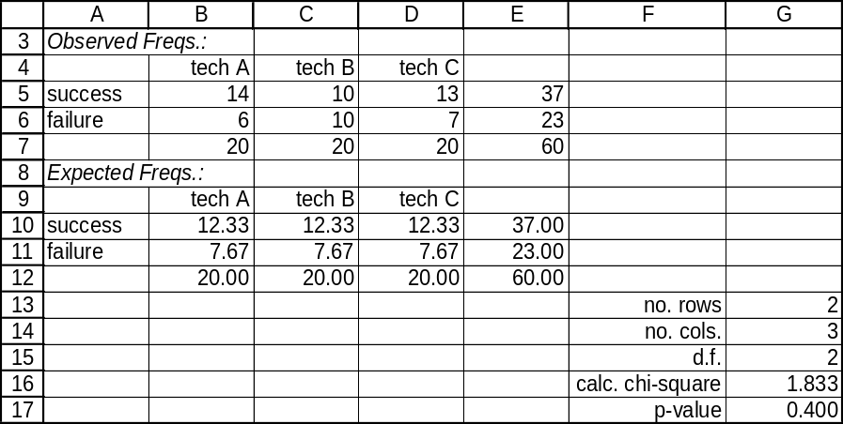

13.75 p/a/d The population variance of interest is 0.03², or 0.0009.
There are 12 - 1 = 11 degrees of freedom for this problem.
The lower limit for the 98% confidence interval for σ² is 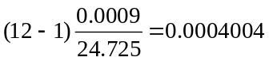.
The upper limit for the 98% confidence interval for σ² is 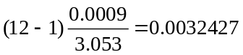.
Therefore, the 98% confidence interval for σ is (0.02001, 0.05694).

Given the summary information in the exercise, we can also use the Estimators workbook that accompanies Data Analysis Plus. The results, expressed in terms of the variance limits, are shown below:
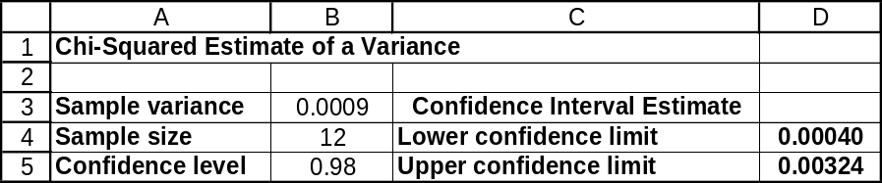

13.76 p/a/d The population variance of interest is 0.8², or 0.64, and the null and alternative hypotheses are H₀: σ² ≥ 0.64 and H₁: σ² < 0.64
The degrees of freedom for this problem are 30 - 1 = 29. This is a lower tail test, so the critical value of chi-square at the 0.05 level is 17.708. The calculated value is 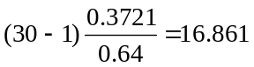.
Since the calculated value is less than the critical value, we reject H₀. There is evidence, at the 0.05 level, that the population standard deviation is less than 0.8 minutes.
Given the summary information in the exercise, we can also use Test Statistics workbook that accompanies Data Analysis Plus. In this one-tail test, p-value = 0.0357 is less than the 0.05 level of significance for the test, so we reject H₀.
Note: In cell B6, we have specified alpha = 0.05, as in our problem statement for our test. However, the one-tail (cell D4) and two-tail (cells D7 and D8) critical values in the printout would be applicable to either a two-tail test at the 0.05 level or a right-tail test at the 0.05 level, so the one-tail critical value in the printout differs from the left-tail critical value calculated above. Most importantly, this does not affect the p-value of 0.0357 on which we base our conclusion. To get a printout with the left-tail critical value of 17.708 calculated above, we would need to specify alpha = 0.10 in cell B6 and refer to the lower critical value of 17.708 that would then be displayed in cell D7.
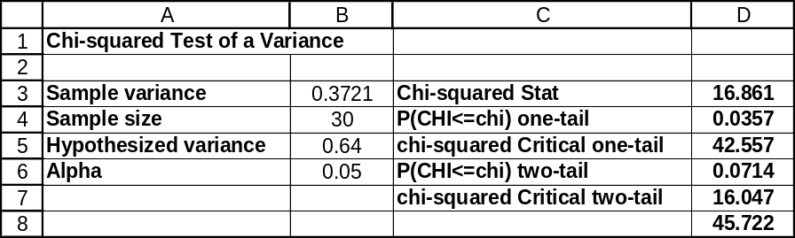

13.77 p/a/m The null and alternative hypotheses are:
H₀: The population percentages are the same for the three income groups
H₁: The population percentages are not the same for the three income groups
With d.f. = (2 - 1)(3 - 1) = 2, the critical value of chi-square at the 0.10 level is 4.605.
In the Minitab printout below, the calculated chi-square exceeds the critical value, and we reject H₀.
At this level, the population percentages for participation in adult education are not the same for the three income groups. Alternatively, because p-value = 0.000 < α = 0.10 level of significance, we reject H₀.

Chi-Square Test: C1, C2, C3

Expected counts are printed below observed counts
Chi-Square contributions are printed below expected counts

C1 C2 C3 Total
1 360 420 480 1260
420.00 420.00 420.00
8.571 0.000 8.571

2 640 580 520 1740
580.00 580.00 580.00
6.207 0.000 6.207

Total 1000 1000 1000 3000

Chi-Sq = 29.557, DF = 2, P-Value = 0.000

13.78 p/a/m The null and alternative hypotheses are
H₀: The population percentage of defectives is the same for the three companies
H₁: The population percentage of defectives is not the same for the three companies. With d.f. = (2 - 1)(3 - 1) = 2, the critical value of chi-square at the 0.025 level is 7.378. We will use Excel worksheet template tmchipro. The calculated chi-square does not exceed the critical value, and we do not reject H₀. At this level, the population percentage of defectives could be the same for the three companies. Alternatively, because p-value = 0.224 is not < α = 0.025 level of significance for the test, we do not reject H₀
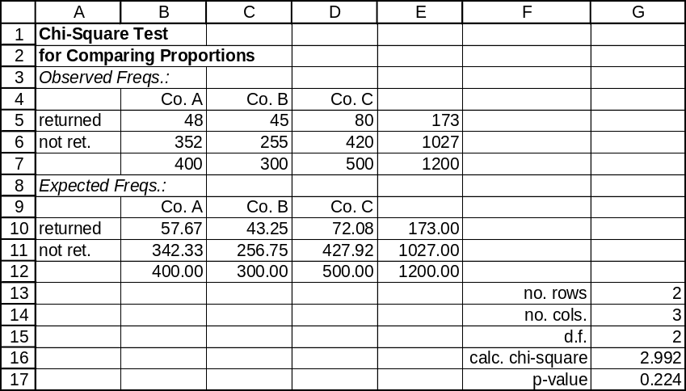.

13.79 p/a/m The null and alternative hypotheses are:
H₀: The population proportions are the same for the three departments
H₁: The population proportions are not the same for the three departments
With d.f. = (2 - 1)(3 - 1) = 2, the critical value of chi-square at the 0.025 level is 7.378. We will use Minitab. The calculated chi-square does not exceed the critical value, and we do not reject H₀. At this level, the population proportions for the three departments could be the same. Alternatively, because
p-value = 0.045 is not < α = 0.025 level of significance for the test, we do not reject H₀.

Chi-Square Test: C1, C2, C3

Expected counts are printed below observed counts
Chi-Square contributions are printed below expected counts

C1 C2 C3 Total
1 20 30 25 75
18.75 25.00 31.25
0.083 1.000 1.250

2 10 10 25 45
11.25 15.00 18.75
0.139 1.667 2.083

Total 30 40 50 120

Chi-Sq = 6.222, DF = 2, P-Value = 0.045

13.80 p/a/d
The lower limit for the 95% confidence interval for σ² is 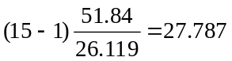.
The upper limit for the 95% confidence interval for σ² is 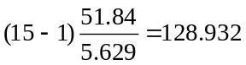.
Therefore, the 95% confidence interval for σ is (5.271, 11.355).
Given the summary information in the exercise, we can also use the Estimators workbook that accompanies Data Analysis Plus. The results, expressed in terms of the variance limits, are shown below. Compared to the variance limits calculated above, these are more accurate because the computer carries more decimal places than are available in our chi-square table.
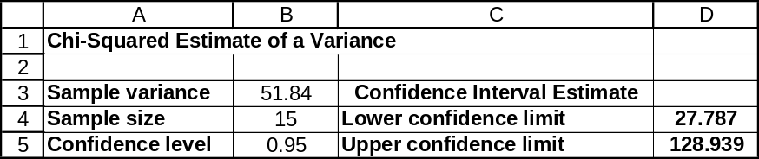

13.81 p/a/m The null and alternative hypotheses are:
H₀: The population percentages are the same for the four colleges
H₁: The population percentages are not the same for the four colleges
With d.f. = (2 - 1)(4 - 1) = 3, the critical value of chi-square at the 0.05 level is 7.815. We will use Excel worksheet template tmchipro. The calculated chi-square exceeds the critical value, and we reject H₀. At this level, the population percentages for support of the football team's move to division I are not the same for the four colleges. Alternatively, because p-value = 0.009 < α = 0.05 level of significance for the test, we reject H₀.
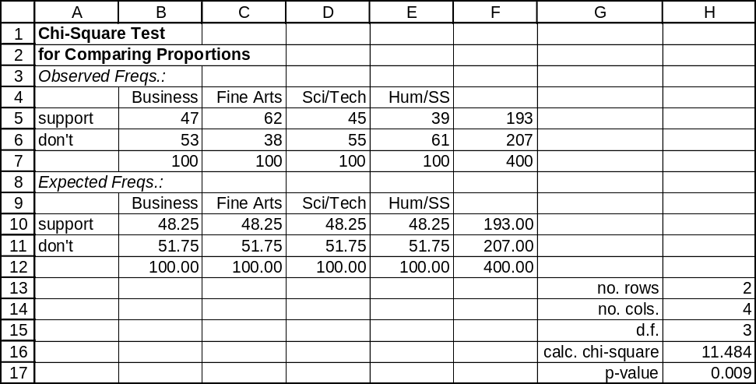

13.82 p/a/d The population variance of interest is 0.4², or 0.16, and the null and alternative hypotheses are H₀: σ² ≤ 0.16 and H₁: σ² > 0.16
The degrees of freedom for this problem are 30 - 1 = 29. If we use the 0.01 level of significance to reach a conclusion in this upper-tail test, the critical value of chi-square will be 49.588.
The calculated value is 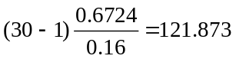.
Since the calculated value exceeds the critical value, we reject H₀. There is evidence, at the 0.01 level, that the population variance exceeds 0.16 (or that σ exceeds 0.4 ounces). One would strongly urge management to shut down the machine. The p-value for the test is less than 0.01.
Given the summary information in the exercise, we can also use the Test Statistics workbook that accompanies Data Analysis Plus. In this one-tail test, p-value = 0.0000 is less than the 0.01 level of significance for the test, so we reject H₀.
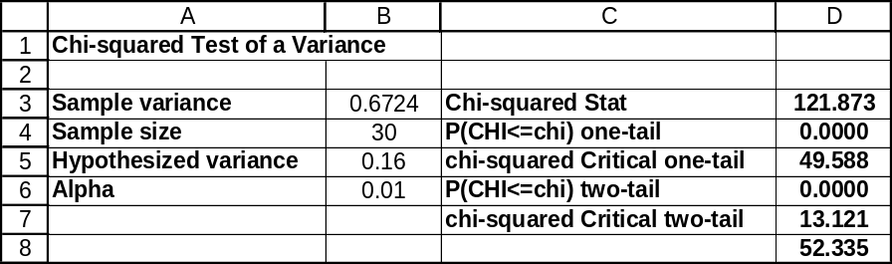

13.83 p/c/m The null and alternative hypotheses are:
H₀: Customer size and accuracy are independent
H₁: Customer size and accuracy are not independent
With d.f. = (3 - 1)(3 - 1) = 4, the critical value of chi-square at the 0.025 level is 11.143. We will use Minitab. The calculated chi-square exceeds the critical value and we reject H₀. Alternatively, because
p-value = 0.023 is less than α = 0.025 level of significance for the test, we reject H₀. At this level, customer size and accuracy are not independent.

Tabulated Statistics: ESTvsUSE, CompSize

Rows: ESTvsUSE Columns: CompSize

1 2 3 All

1 53 112 46 211
2 19 31 34 84
3 32 57 35 124
All 104 200 115 419

Chi-Square = 11.302, DF = 4, P-Value = 0.023

Cell Contents --
Count

13.84 p/c/m The null and alternative hypotheses are:
H₀: The data are drawn from a normal population
H₁: The data are not drawn from a normal population
We will use Data Analysis Plus to examine whether if the data could have come from a normal population. The sample mean and standard deviation were used in estimating their population counterparts, so m = 2 in the d.f. = k - 1 - m calculation, and d.f. = 2. The critical value of chi-square at the 0.025 level is 7.378. The calculated value (7.267) does not exceed this critical value and we are not able to reject H₀ at the 0.025 level of significance. Alternatively, p-value = 0.0264 is not less than the 0.025 level of significance being used to reach a conclusion, so we do not reject H₀.
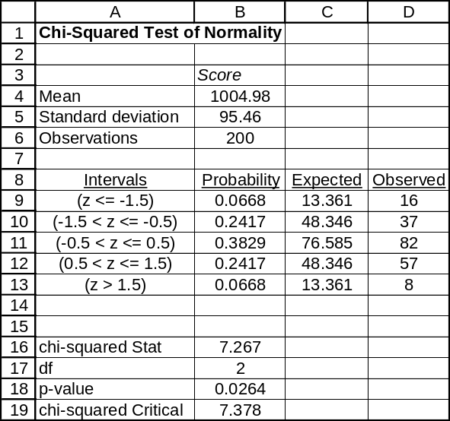

13.85 p/c/d The null and alternative hypotheses are:
H₀: The number of TV sets per household is Poisson distributed
H₁: The number of TV sets per household is not Poisson distributed
First, we use Minitab to determine the sample mean -- this value is 2.300 televisions per household.
We then use Minitab to tally the frequency with which each value occurs and to describe the individual and cumulative probability distributions for a Poisson distribution having a mean of 2.300.

Descriptive Statistics: NumbSets

Variable N Mean Median TrMean StDev SE Mean
NumbSets 100 2.300 2.000 2.244 1.474 0.147

Variable Minimum Maximum Q1 Q3
NumbSets 0.000 6.000 1.000 3.000

Tally for Discrete Variables: NumbSets

NumbSets Count
0 7
1 27
2 28
3 18
4 10
5 7
6 3
N= 100

Probability Density Function Cumulative Distribution Function

Poisson with mu = 2.30000 Poisson with mu = 2.30000

x P( X = x ) x P( X <= x )
0.00 0.1003 0.00 0.1003
1.00 0.2306 1.00 0.3309
2.00 0.2652 2.00 0.5960
3.00 0.2033 3.00 0.7993
4.00 0.1169 4.00 0.9162
5.00 0.0538 5.00 0.9700

Next, we determine the expected frequencies for each x value. For example, the expected frequency for
x = 1 is 0.2306(100) = 23.06. We have combined the two highest categories in order that each expected count will be ≥ 5. As a result, the expected frequency for x ≥ 5 TV sets is (1 - 0.9162)(300) = 8.38.
We will now use Excel worksheet template tmchifit. Note that the d.f. value is calculated as
d.f. = k - 1 - m, or d.f. = 5 - 1 - 1 = 3. The “m” term is 1 because we have used the sample mean (2.300) to estimate its (unknown) population counterpart. The calculated value does not exceed the critical value at the 0.025 level, and we do not reject H₀. Alternatively, using the p-value approach, we do not reject H₀ because p-value = 0.645 is not less than α = 0.025 level of significance for the test. At this level, we conclude that the number of TV sets per household could be Poisson distributed.
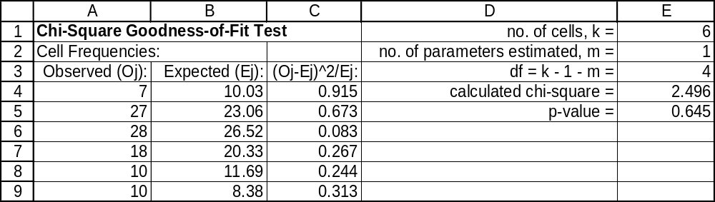

13.86 p/c/m The null and alternative hypotheses are:
H₀: Household income and the number of vehicles owned are independent
H₁: Household income and the number of vehicles owned are not independent
With d.f. = (3 - 1)(4 - 1) = 6, the critical value of chi-square at the 0.025 level is 14.449. As shown in the Minitab printout below, the calculated chi-square exceeds the critical value, and we reject H₀. Alternatively, because p-value = 0.000 is < α = 0.025 level of significance for the test, we reject H₀.
At this level, household income and the number of vehicles owned are not independent.

Tabulated Statistics: NumbVehs, IncLevel

Rows: NumbVehs Columns: IncLevel

1 2 3 4 All

1 16 12 2 4 34
2 27 70 74 31 202
3 4 13 22 25 64
All 47 95 98 60 300

Chi-Square = 52.473, DF = 6, P-Value = 0.000

Cell Contents -- Count

13.87 p/a/d The null and alternative hypotheses are:
H₀: σ² ≤ 25 and H₁: σ² > 25
The degrees of freedom for this problem are 51 - 1 = 50. This is an upper tail test, so the critical value of chi-square at the 0.025 level is 71.420, as shown in the printout below that was generated using Excel and Data Analysis Plus. The calculated chi-square is 74.420, and this exceeds the critical value of 71.420. Since the calculated value exceeds the critical value, we reject H₀. From a p-value standpoint, the p-value in this one-tail test is 0.0141, which is less than the 0.025 level of significance, so we reject H₀. At this level, the researchers would appear to be correct in their assertion that too much variability exists in the speeds of vehicles passing this location.
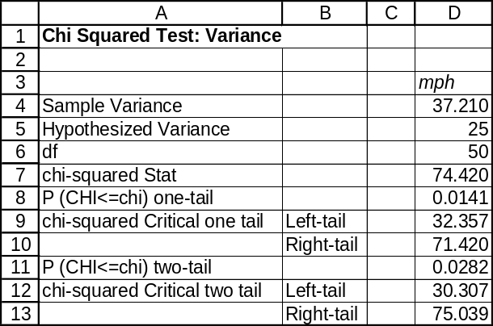

13.88 p/c/d Using Excel and Data Analysis Plus, the 95% confidence interval for the population variance is from 26.0501 to 57.4985, as shown below. Alternatively, we can obtain the 95% confidence interval using summary information and the Estimators workbook that accompanies Data Analysis Plus.
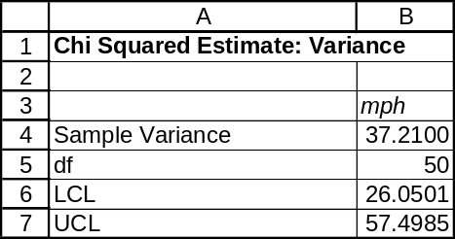

INTEGRATED CASES

THORNDIKE SPORTS EQUIPMENT

Ted is testing the variability of pitches thrown by the Thorndike Rapid Robot. If the standard deviation is significantly less than 3.5 inches, the Alvindale Chipmunks will purchase the machine. The robot has thrown thirty pitches, so the d.f. = 30 - 1 = 29.

Mr. Johnson has specified the 0.01 level of significance, and this is a left-tail test ("significantly less
than 3.5 inches"). Therefore, the critical value of chi-square is 14.256. In terms of the value for variance (or 3.5² = 12.25), the null and alternative hypotheses are H₀: σ² ≥ 12.25 and H₁: σ² < 12.25.

Using Minitab to obtain the summary statistics for the sample of n = 30 pitches by the Thorndike Rapid Robot:

Descriptive Statistics: Inches

Variable N Mean SE Mean StDev Minimum Q1 Median Q3 Maximum
Inches 30 27.377 0.419 2.294 22.700 26.025 26.950 28.925 32.100

The sample variance is s² = (2.294)², or 5.26. The calculated test statistic is 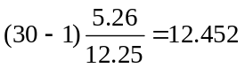.

In this left-tail test, the calculated value (12.452) is less than the critical value (14.256), so we reject H₀. At the 0.01 level, the standard deviation for the Thorndike Rapid Robot is significantly less than 3.5 inches. Mr. Johnson will sign Mr. Rapid Robot as a mechanical member of the Chipmunks.

Alternatively, we can use Data Analysis Plus and the printout below to predict Mr. Johnson’s decision.
The results are comparable to, and slightly more accurate than, our computations above that were based on summary statistics, the chi-square table, and the pocket calculator. Because the test is left-tail and
p-value = 0.003 is < the 0.01 level of significance being used to reach a conclusion, we can conclude that Mr. Rapid Robot will soon be an official member of the Alvindale Chipmunks.
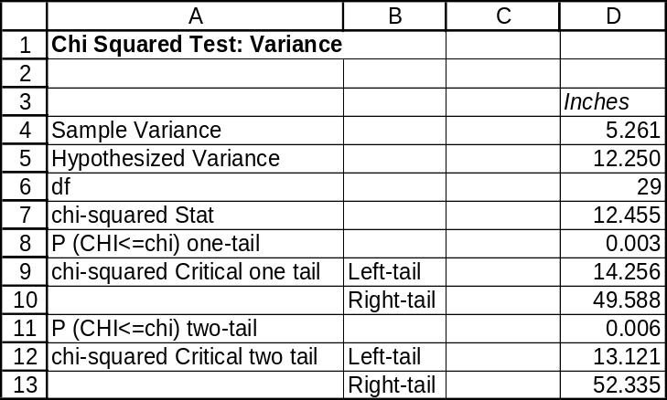

SPRINGDALE SHOPPING SURVEY

PART I: RESPONDENT CHARACTERISTICS AND THE AREA JUDGED BEST FOR BARGAINS

1. Contingency table and chi-square analysis for variables 26 and 17.

Tabulated Statistics: RESPGEND, BSTBARGN

Rows: RESPGEND Columns: BSTBARGN

1 2 3 4 All

1 14 16 19 9 58
2 34 17 36 5 92
All 48 33 55 14 150

Chi-Square = 7.436, DF = 3, P-Value = 0.059

Cell Contents --
Count

The p-value for the test is 0.059, and this is not < α = 0.05, the level of significance for the test.
At this level, we do not reject H₀. At this level, we conclude that the gender of the respondent could be independent of the shopping area judged best for bargains.

2. Contingency table and chi-square analysis for variables 27 and 17.

Tabulated Statistics: RESPEDUC, BSTBARGN

Rows: RESPEDUC Columns: BSTBARGN

1 2 3 4 All

1 2 0 2 0 4
1.28 0.88 1.47 0.37 4.00

2 14 3 20 1 38
12.16 8.36 13.93 3.55 38.00

3 20 20 21 6 67
21.44 14.74 24.57 6.25 67.00

4 12 10 12 7 41
13.12 9.02 15.03 3.83 41.00

All 48 33 55 14 150
48.00 33.00 55.00 14.00 150.00

Chi-Square = 15.985, DF = 9
* WARNING * 2 cells with expected counts less than 1.0
* Chi-Square approximation probably invalid
6 cells with expected counts less than 5.0

Cell Contents --
Count
Exp Freq

Because some of the expected frequencies are less than 5, we combine rows 1 and 2 and
columns 3 and 4. Repeating the chi-square analysis for these variables:

Chi-Square Test: C1, C2, C3

Expected counts are printed below observed counts
Chi-Square contributions are printed below expected counts

C1 C2 C3 Total
1 16 3 23 42
13.44 9.24 19.32
0.488 4.214 0.701

2 20 20 27 67
21.44 14.74 30.82
0.097 1.877 0.473

3 12 10 19 41
13.12 9.02 18.86
0.096 0.106 0.001

Total 48 33 69 150

Chi-Sq = 8.053, DF = 4, P-Value = 0.090

The p-value for the test is 0.090, and this is not < α = 0.05, the level of significance for the test. At this level, we do not reject H₀. At this level, we conclude that the education level of the respondent could be independent of the shopping area judged best for bargains.

PART II: RESPONDENT CHARACTERISTICS

1. Contingency table and chi-square analysis for variables 26 and 27.

Tabulated Statistics: RESPGEND, RESPEDUC

Rows: RESPGEND Columns: RESPEDUC

1 2 3 4 All

1 1 9 25 23 58
1.55 14.69 25.91 15.85 58.00

2 3 29 42 18 92
2.45 23.31 41.09 25.15 92.00

All 4 38 67 41 150
4.00 38.00 67.00 41.00 150.00

Chi-Square = 9.216, DF = 3, P-Value = 0.027
2 cells with expected counts less than 5.0

Cell Contents --
Count
Exp Freq

So that no expected frequencies will be < 5.0, , we combine columns 1 and 2:

Chi-Square Test: C1, C2, C3

Expected counts are printed below observed counts
Chi-Square contributions are printed below expected counts

C1 C2 C3 Total
1 10 25 23 58
16.24 25.91 15.85
2.398 0.032 3.222

2 32 42 18 92
25.76 41.09 25.15
1.512 0.020 2.031

Total 42 67 41 150

Chi-Sq = 9.214, DF = 2, P-Value = 0.010

The p-value for the test is 0.010, which is < α = 0.05, the level of significance for the test. At this level, we reject H₀ and conclude that the variables are not independent. It appears that the gender of the respondent is related to the respondent's educational level.

2. Contingency and chi-square analysis table for variables 26 and 28.

Tabulated Statistics: RESPGEND, RESPMARI

Rows: RESPGEND Columns: RESPMARI

1 2 All

1 24 34 58
25.91 32.09 58.00

2 43 49 92
41.09 50.91 92.00

All 67 83 150
67.00 83.00 150.00

Chi-Square = 0.413, DF = 1, P-Value = 0.520

Cell Contents --
Count
Exp Freq

The p-value for the test is 0.520, which is not < α = 0.05, the level of significance for the test. At this level, we do not reject H₀, and we conclude that the variables are independent. It appears that the gender of the respondent is not related to the respondent's marital status.

BUSINESS CASE

BALDWIN COMPUTER SALES (C)

In the Baldwin Computer Sales case, visited earlier in chapters 3 and 5, one of the areas of concern regarding the student purchase program was whether defaulting on the computer payments might be independent of the university attended by the student. Using Minitab and the BALDWIN data file on the text CD, we have applied the chi-square test for variable independence as shown below. When there are just two rows in the contingency table, this is the same as the chi-square test for equality of population proportions. The p-value (0.569) is not less than 0.01, 0.05, 0.10, or any other reasonable level of significance we would typically apply in reaching a conclusion for such a test. Thus, despite the fact that participants from the various schools have differed in terms of their default rates in the past, we conclude that these differences could be due to chance and that these variables could be independent.

Tabulated statistics: Default, School

Rows: Default Columns: School

1 2 3 4 5 All

0 35 52 62 35 21 205
40.16 50.95 62.34 31.17 20.38 205.00

1 32 33 42 17 13 137
26.84 34.05 41.66 20.83 13.62 137.00

All 67 85 104 52 34 342
67.00 85.00 104.00 52.00 34.00 342.00

Cell Contents: Count
Expected count

Pearson Chi-Square = 2.936, DF = 4, P-Value = 0.569

